How to construct Histogram

|  |  |
| --- | --- |
| X | P(X) |
| 0 | 1/16 |
| 1 | 4/16 |
| 2 | 6/16 |
| 3 | 4/16 |
| 4 | 1/16 |

As we all know that to present the PDF of a discrete random variable we use histogram and to represent the CDF we use the step graph.

Let you have given the function below

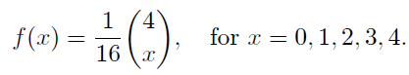

And the histogram will be

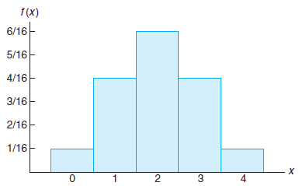

Plot the variables of x along x axis and P(X) along y axis.

To construct the CDF graphical representation we need line graph

Suppose given below is the CDF of the above function

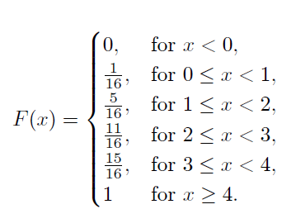

And the line graph for the function is

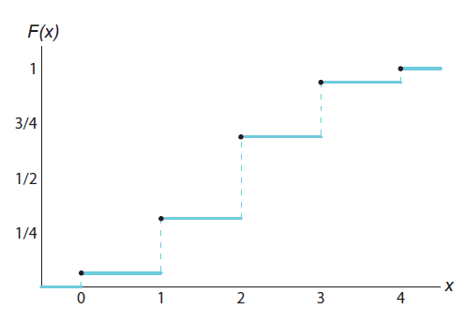

As you can see that random variable x is plotted along x axis and F(X) along y axis.

See the graph; you don’t have 0 on the origin but away from the origin at x axis (same as histogram) because 0 is a random variable and not the point at origin)

Now as according to the CDF P(x<0)= 0 so draw a line at x axis till the point 0

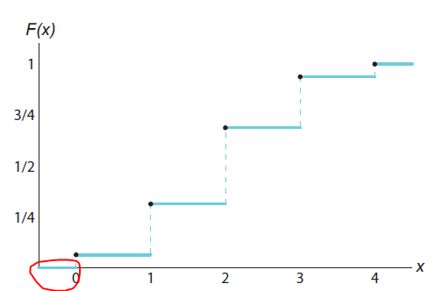

then F(x) for 0 ≤ x < 1 is 1/16 so draw a line parallel to x axis from 0 to 1 at point 1/16 at y axis.

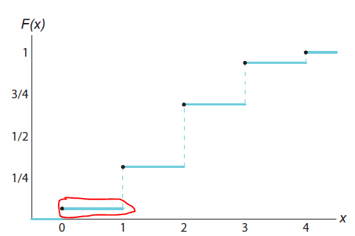

In the same way F(x) for 1 ≤ x < 2 is 5/16 so draw a line from 1 to 2 parallel to x axis at point 5/16 at y axis.

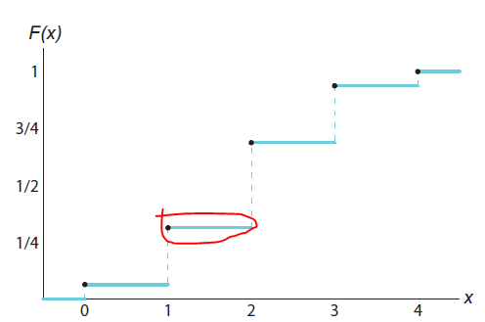

And so complete the graph

Now as you can see the graph, point 1 is joined with the line at 1 to 2 with a dotted line forming a step

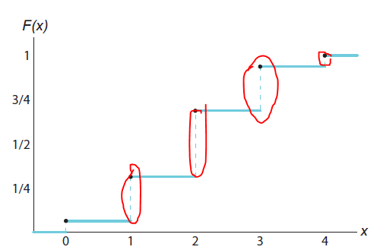

so the graph is known as step graph